GOOD STORIES TEMPLATE

- Name of the Project

The name of the project is the Upper Breede River: Restoration and Greening LandCare Project.

2. Who runs the project?
The project was implemented by the Western Cape Department of Agriculture through the LandCare conditional grant.
3. Location of the project
The project is situated in the Worcester Municipality District. It is located at Latitude: 33 40’ 00” South and Longitude: 19 23’ 00” East.
4. Background Information/Introduction
The project started in the 2014/15 financial year. The main objectives of the project were to raise awareness amongst landowners and schools, provide trees and pioneer plants to landowners and plant trees at schools and farms. The project was established by the Breede River valley community and, as indicated in their mission statement, focuses on the upliftment of the farming community and farm workers by creating opportunities. The community identified a need for this project because of the direct impact that invasive alien plants has on the natural environment including the loss of rare species, displacement of indigenous population that increased fire intensity, soil erosion, interception of catchment runoff, downstream impacts on biodiversity and functioning of aquatic ecosystem. The project is led by people in the community who have an interest in the health of the environment and integrates the concept of locally-led conservation. The Upper Breede River: Restoration, Greening and Alien Clearing Project was restoring the integrity of the Breede River – a key water source for a large part of the Western Cape. The project operates in the Wolseley area in the Cape Winelands District. It has introduced an innovative new model, where Government, landowners, conservation authorities and companies work together to restore and protect the region's natural resources.
5.The beneficiaries of the project
The direct and indirect beneficiaries.
6. Type of assistance that has been provided by government funding, training, etc.
The project has been funded since the financial year 2015/16 with R200 000 by the Department of Agriculture, Forestry and Fisheries through the LandCare conditional grant and an equable share of R33 000 from the province. The overall expenditure of the project was R233 000. 14 unemployed people received training. The awareness campaigns were conducted to educate the farmers about the health and restoration of the river.

7. The contribution of project to food security, economic growth and job creation
75 job opportunities were created for clearing invasive species; 30 jobs created at the Kluitjieskraal Nursery and additional jobs for wood contractors. The nursery produces indigenous seedlings. The project won the best WaterCare award at the 2014 Biennial National LandCare Conference. The Upper Breede River: Restoration, Greening and Alien Clearing Project has provided livelihoods to hundreds of people throughout the year in an area where work is often seasonal. It provided better lives for those employed and their families and also for those dependent on a healthy and functioning river system. It offers better landscapes in the region where this vital natural resource rehabilitation is taking place as well.

8. Is there any other information that you would like to add?
The former Western Cape Minister of Agriculture, Gerrit van Rensburg, labeled the project as "pioneering." Partners have joined forces to together manage the costs, the management requirements and the monitoring of the project. In fact, the Department of Agriculture is now looking to roll out the model to new projects.

9. Attachments (Graphs, Photos, etc.)
Below photo: Beneficiaries control alien plants Below photo: Alien plants controlled along the Breeder River
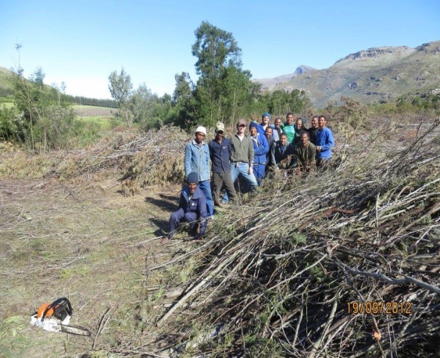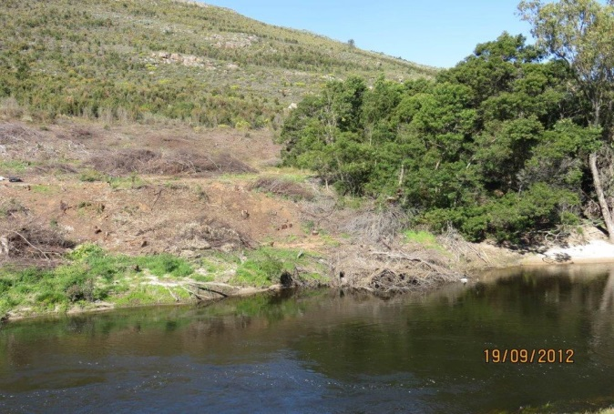
Kluitjieskraal Nursery Beneficiaries planting indigenous plants where alien plants were controlled
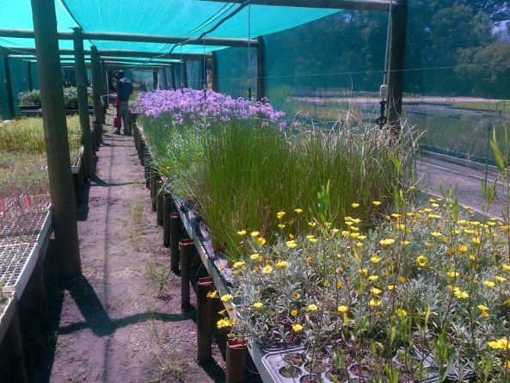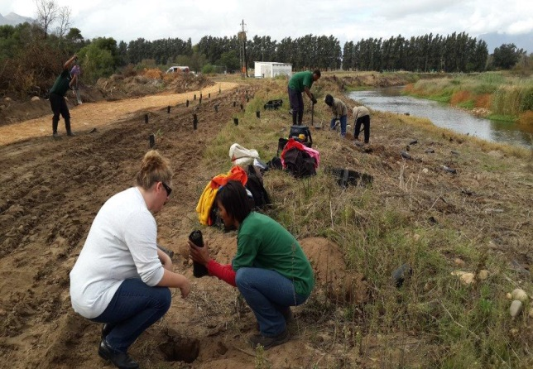

Below photo: The beneficiaries planting indigenous species in the Kluitjieskraal Nursery
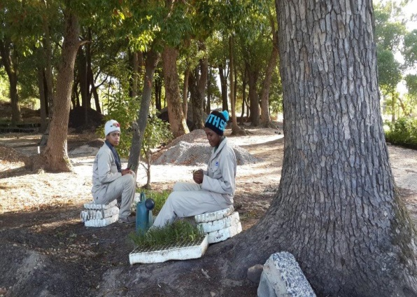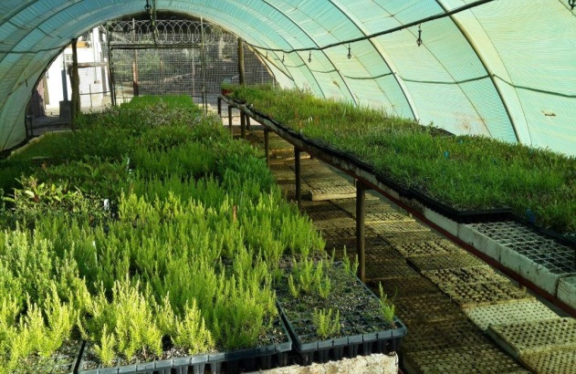

10. Contact person to assist with project visit
For further enquiries regarding the project, kindly liaise with Western Cape Provincial LandCare coordinator, Mr Francis Steyn on Tel no.: (021) 808 5006 or Cell no.: 082 907 2813 or alternatively, email: FrancisS@elsenburg.com

